Question 1
Top Categories by Total Price:
Identify and visually represent the top 10 product categories by total sales.

Visualization
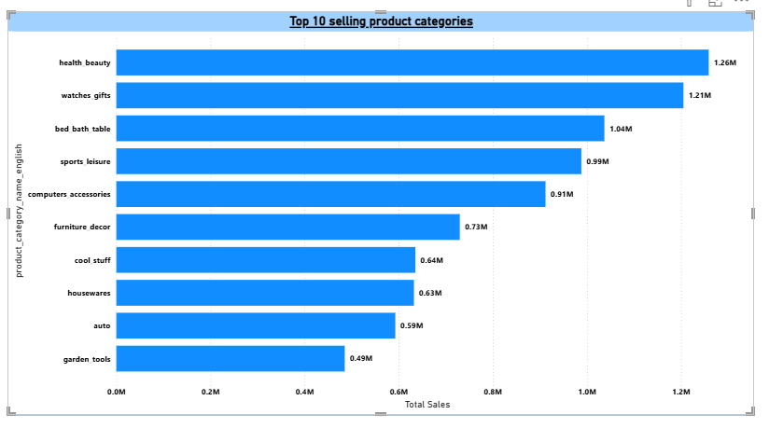

Explanation
This visual highlights the top 10 product categories generating the highest total sales for the ShopNest store.
It helps quickly identify which categories contribute the most to overall revenue, enabling better business focus.
The chart supports data-driven decisions in inventory planning, marketing, and category-level strategy.
The visual shows that Health_Beauty is the highest revenue-generating category, indicating strong customer demand, while Garden_Tools ranks lowest among the top 10 categories, contributing comparatively less to total sales.

Question 2
Delayed Orders Analysis:
Determine the number of delayed orders in each category. An order is considered delayed if the actual delivery date is later than the estimated delivery date.

Visualization
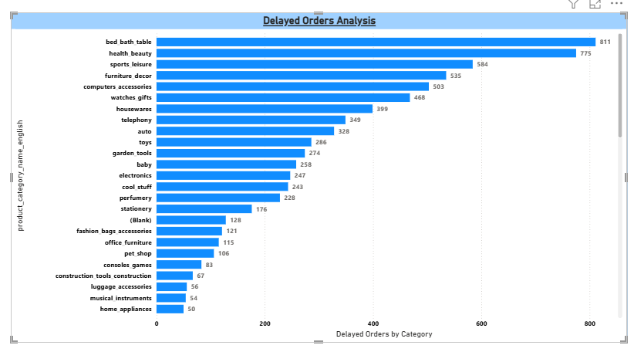
Explanation
This visual analyzes delayed orders by product category, identifying where delivery timelines are most impacted.
Bed Bath Table has the highest number of delayed orders (811), indicating potential logistics or demand-related challenges in this category, while Home Appliances shows the lowest delays (50), reflecting more reliable delivery performance.
These insights help focus operational improvements on categories with higher delivery risk.

Question 3
Monthly comparison of delayed and on-time orders
Create a dynamic visual that compares the number of delayed orders to the number of orders received earlier for each month. Utilize the drill through cross report feature to provide a detailed analysis of late and on-time deliveries.
Visualization
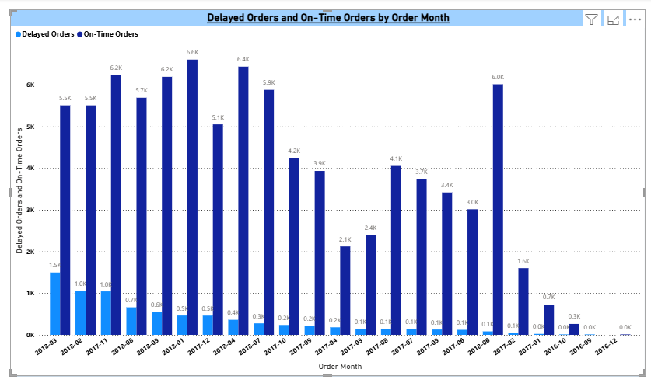
Explanation
This visual compares monthly delayed and on-time orders to highlight delivery performance trends over time.
It uses a drillthrough feature to allow deeper analysis, enabling users to click on a month and view detailed order-level insights for both late and on-time deliveries.
This approach helps identify problematic periods and supports data-driven decisions to improve fulfillment efficiency.
Here highest delayed order on 2018-03 and on time order on 2018-01 and lowest delayed order and on time order both are same 2016-12

Question 4
Payment Method Analysis:
Analyze the most frequently used payment methods by customers using a visually appealing representation, such as a pie chart or other suitable visuals.

Visualization
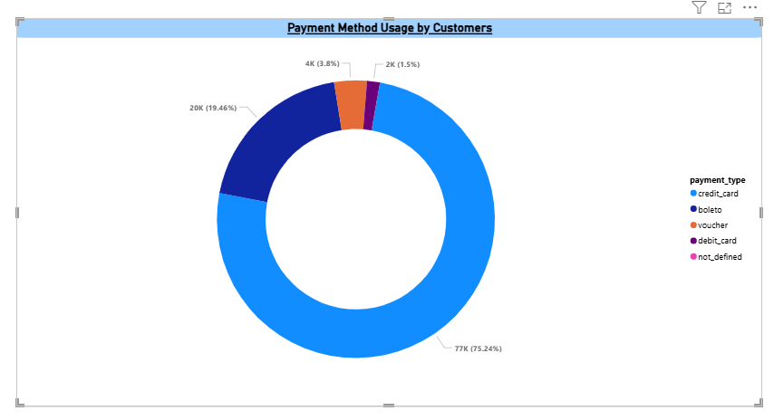

Explanation
This visual presents a payment method analysis, showing how customers prefer to complete their purchases.
Credit cards dominate with 75.24% of total transactions, indicating they are the most preferred payment option, while debit cards account for only 1.5%, making them the least used method.
These insights help businesses optimize payment options and checkout strategies to improve customer experience.

Question 5
Product Rating Analysis:
Determine the top 10 highest-rated products and the bottom 10 lowest-rated products using a bar or column chart.

Visualization
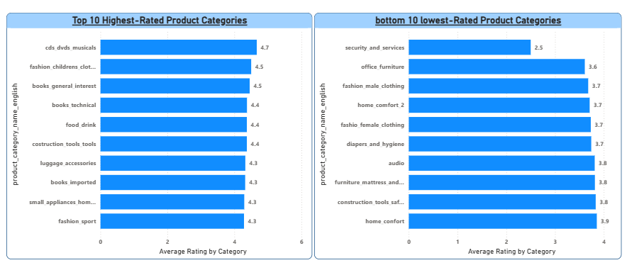

Explanation
This visual compares the top 10 highest-rated and bottom 10 lowest-rated product categories based on average customer ratings.
Categories such as CDs, DVDs & Musicals and Fashion Children’s Clothing receive the highest ratings, reflecting strong customer satisfaction, while categories like Security & Services and Office Furniture show lower ratings, indicating areas for improvement.
This analysis helps identify high-performing categories to sustain quality and low-rated categories that require attention to enhance customer experience.

Question 6
State-wise Sales Analysis:
Identify and visually represent states with high and low sales, providing a clear understanding of regional sales performance.

Visualization
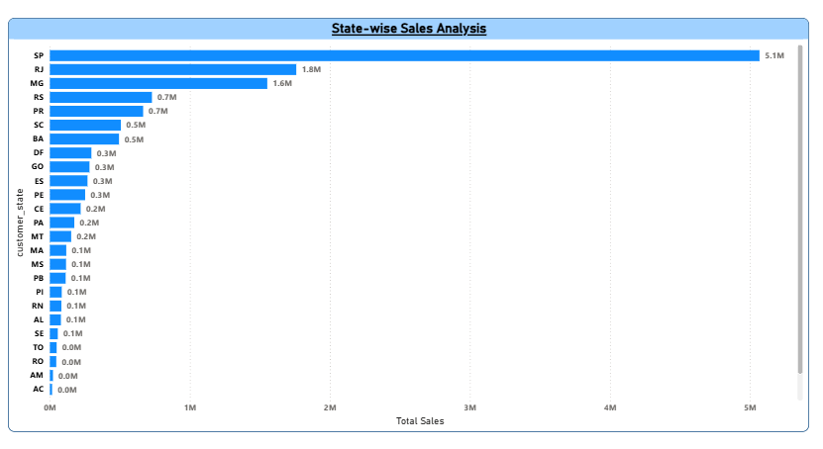

Explanation
This visual analyzes state-wise sales performance, highlighting regional differences in revenue contribution.
São Paulo (SP) leads with approximately 5.1M in total sales, indicating it is the strongest market for the business, while Acre (AC) records minimal or no sales at 0.0M, showing very low customer activity.
These insights help prioritize high-performing regions and identify underperforming states for targeted growth strategies.

Question 7
Seasonal Sales Patterns:
Investigate and visualize any seasonal patterns (Quarterly) or trends in sales data over the course of the year.

Visualization
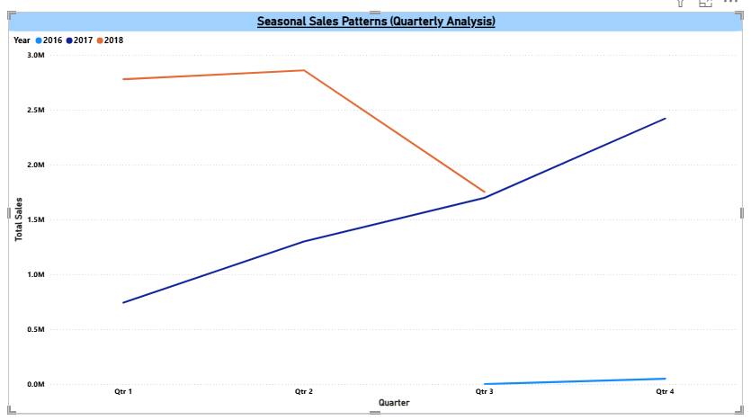
Explanation
This visual illustrates quarterly sales trends across different years, highlighting seasonal patterns in revenue performance.
Sales show a strong increase from Q1 to Q2, followed by a noticeable dip in Q3, and then recover sharply in Q4, indicating end-of-year demand.
These patterns help the business anticipate peak and slow seasons, enabling better planning for inventory, marketing, and operations.

Question 8
Revenue Analysis:
Determine the total revenue generated by ShopNest Store and analyze how it changes over time (Yearly). Represent this information through suitable visuals to highlight trends and patterns.
Visualization
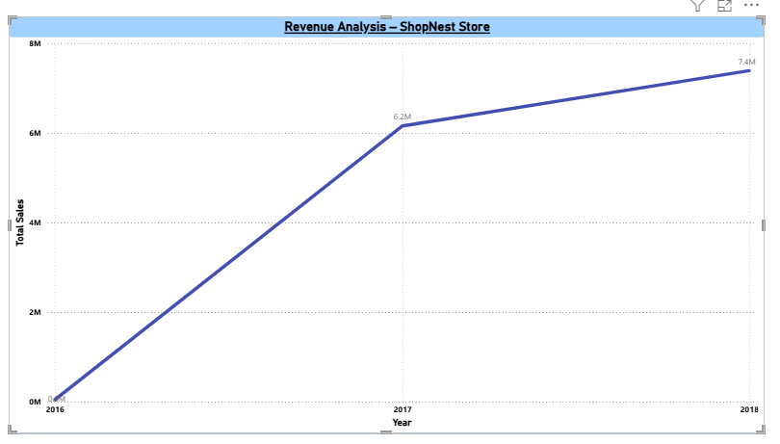
Explanation
This visual shows the yearly revenue trend for the ShopNest store, highlighting how total sales have evolved over time.
Revenue increases sharply from 2016 to 2017, followed by continued growth into 2018, indicating strong business expansion.
The upward trend reflects improving sales performance and growing customer demand year over year.

